Virtual Network – Virtual Mahine

1.create virtual network

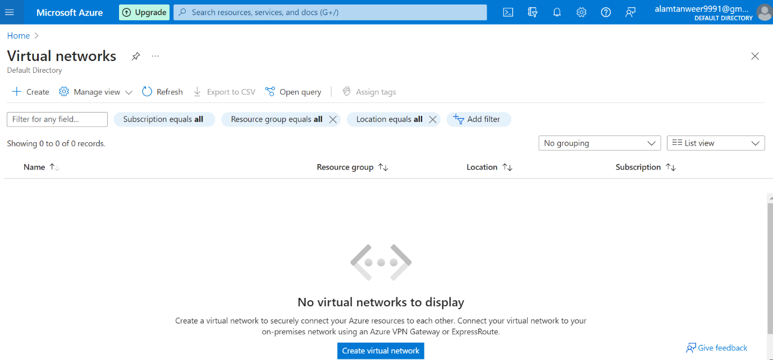

1.create virtual network

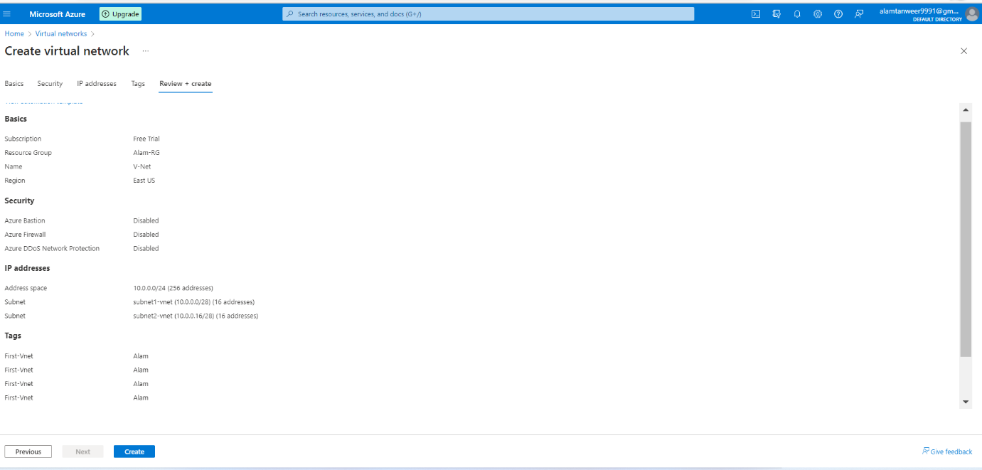

3. Create Virtual Network

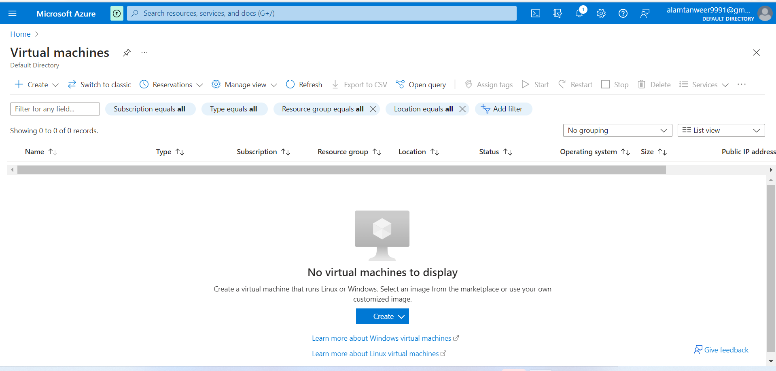

3.subnets with 16 ips- 5 reserverd by azure

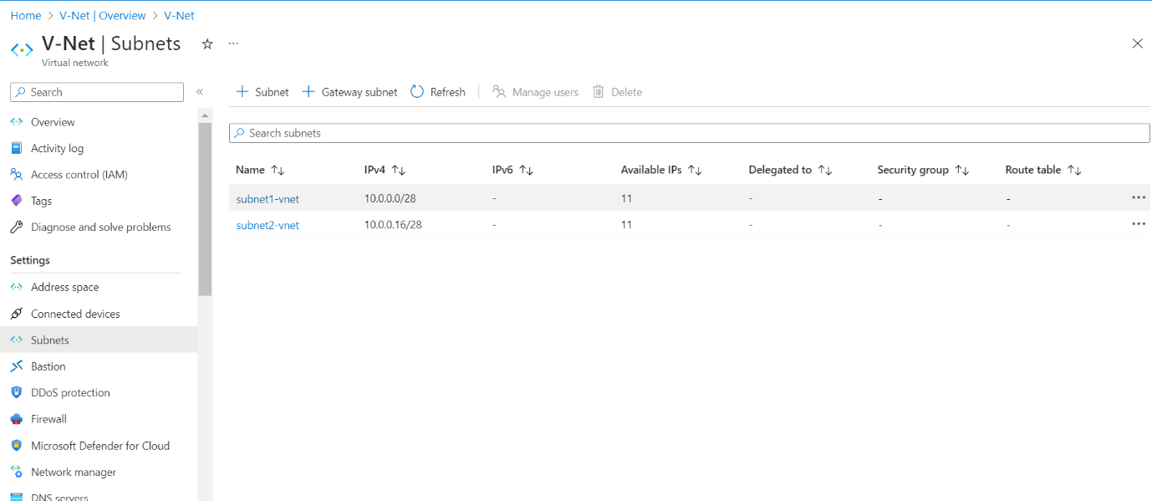

5. Virtual Machine - all config

6. Virtual Machine - all config

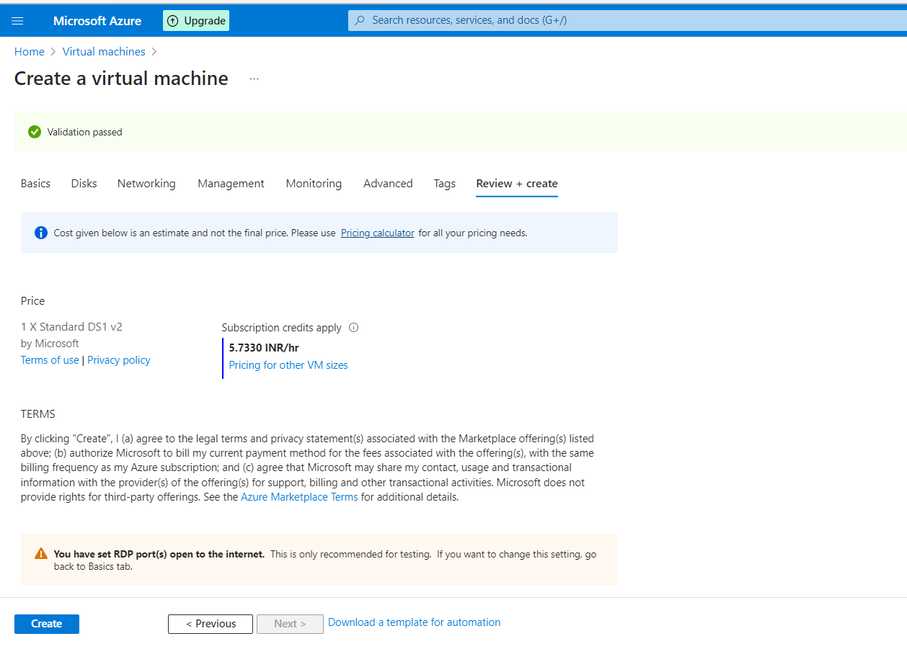

8. Virtual Machine - all config

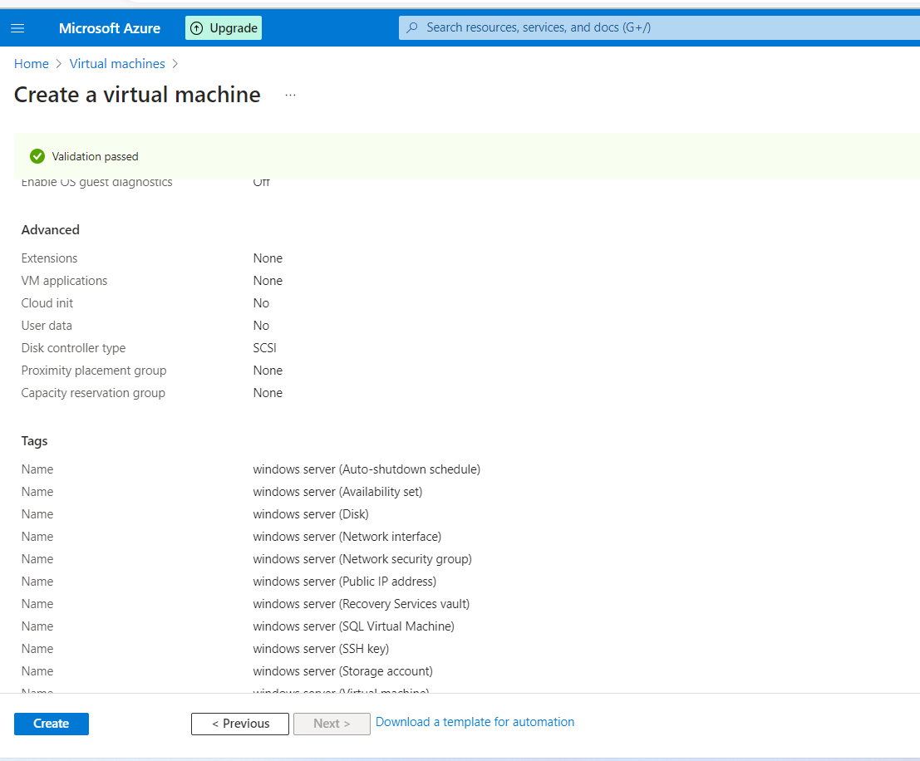

9. VM - created successfully

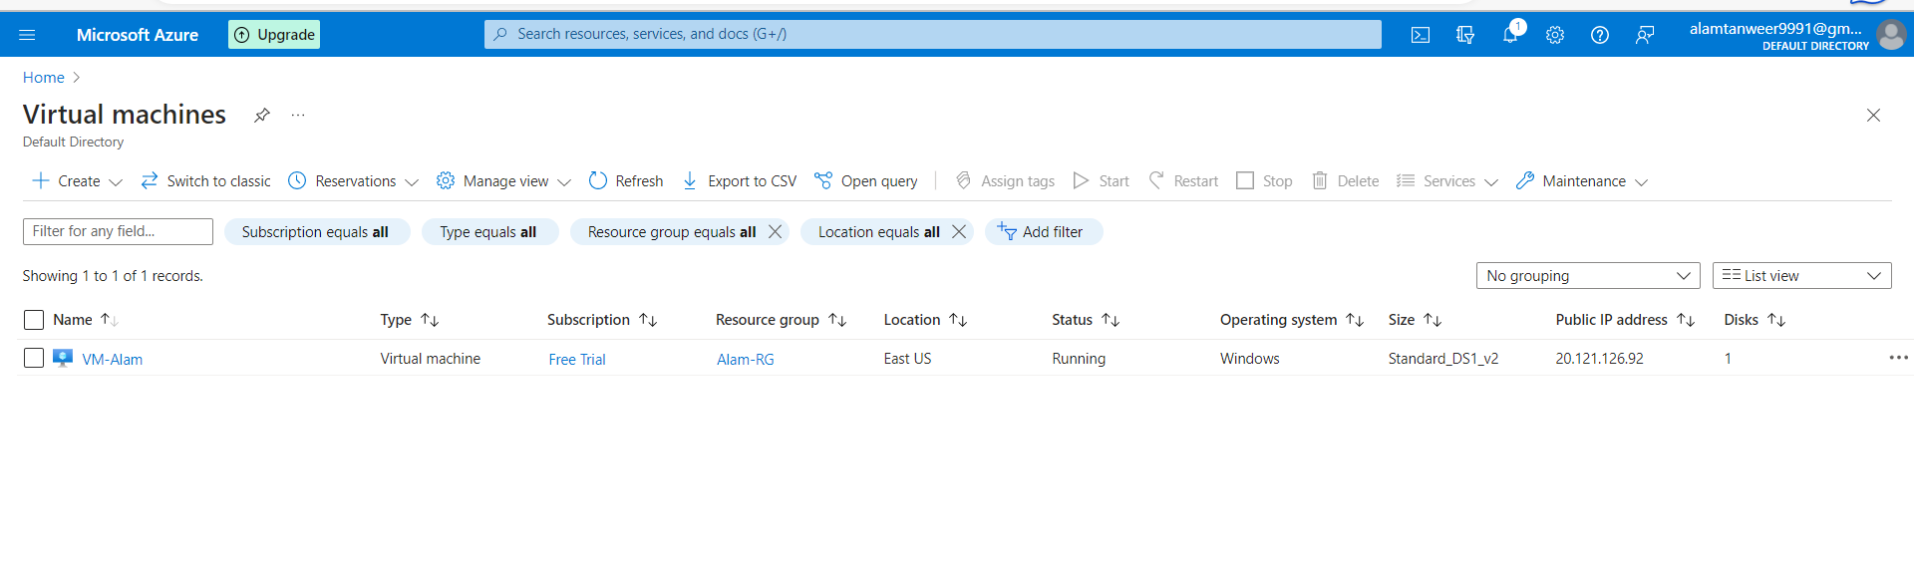

10. Create MySql Database

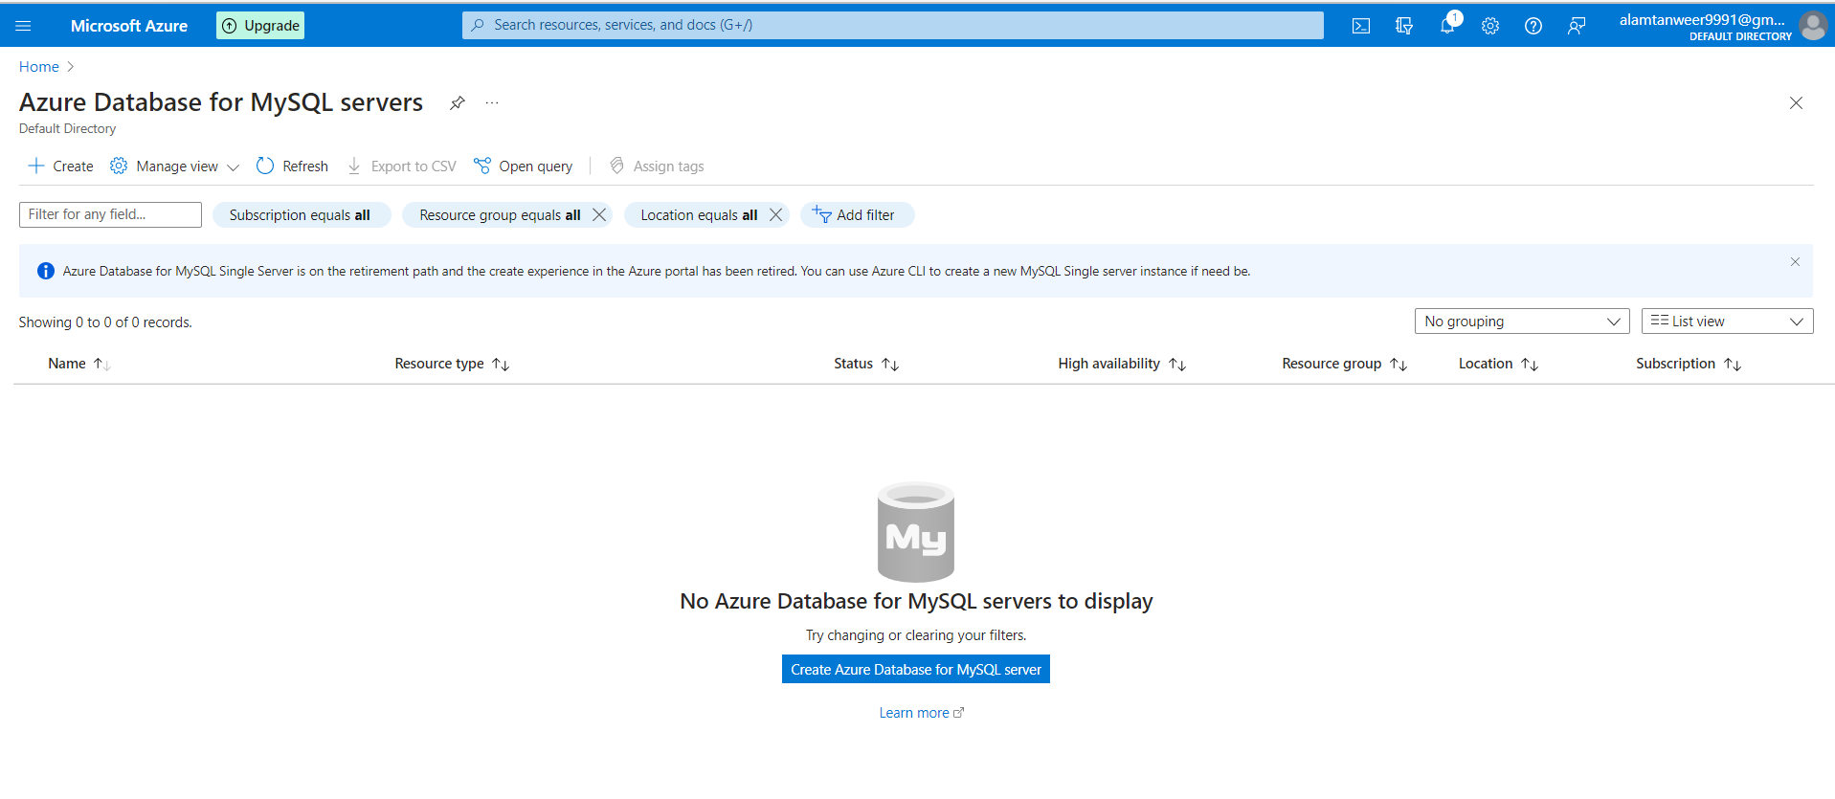

11. MySqlDB -config

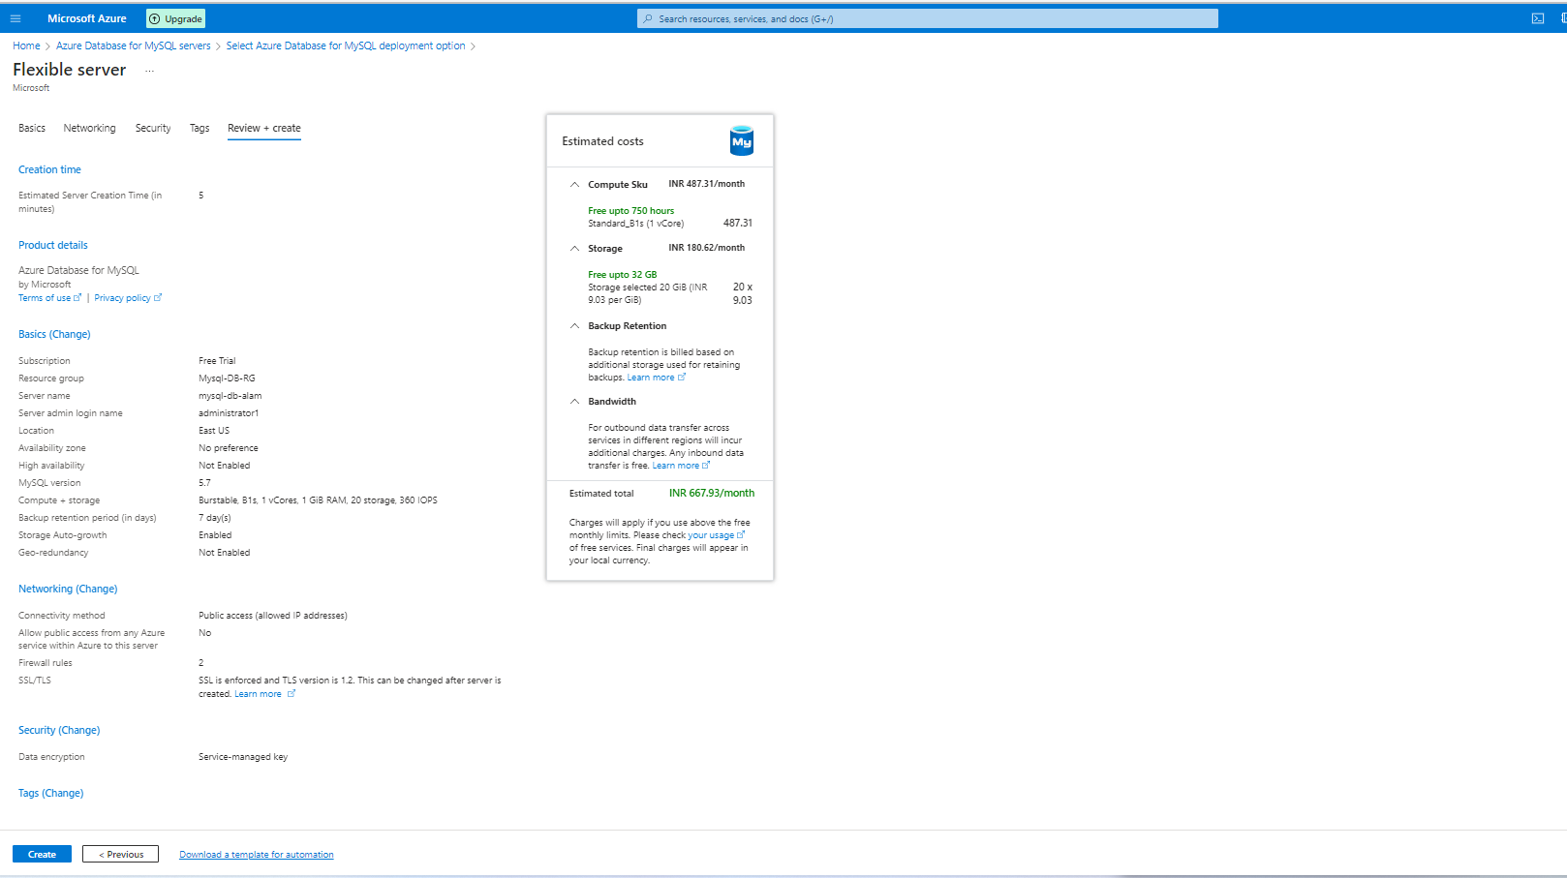

12. Created DB successfully.

13. Launching VM through RDP

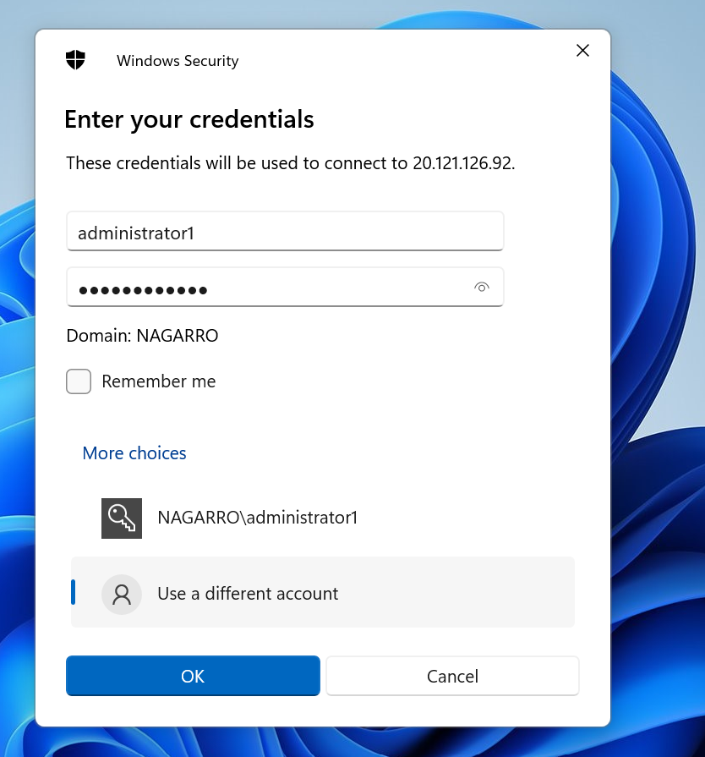

14. Successfully launched VM on Public IP address - 20.121.126.92

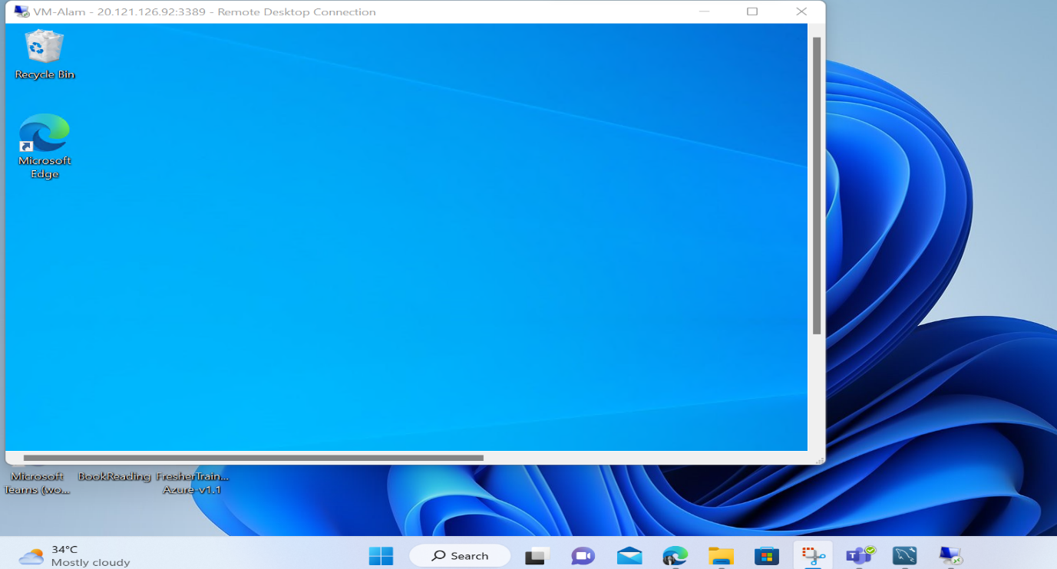

15. This is the Node App which I have deployed on VM.

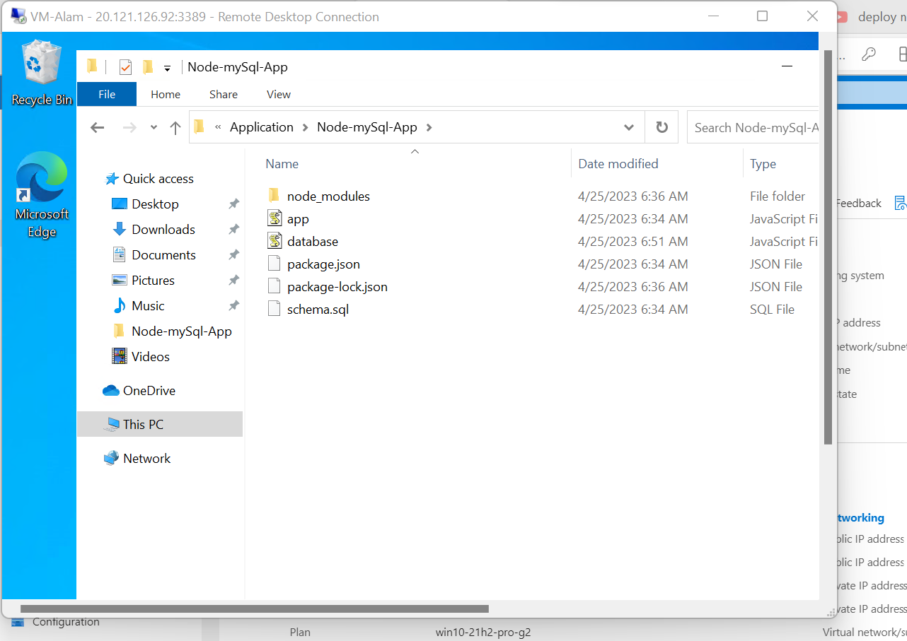

16. In this file I have configured the MySQL db connection string.

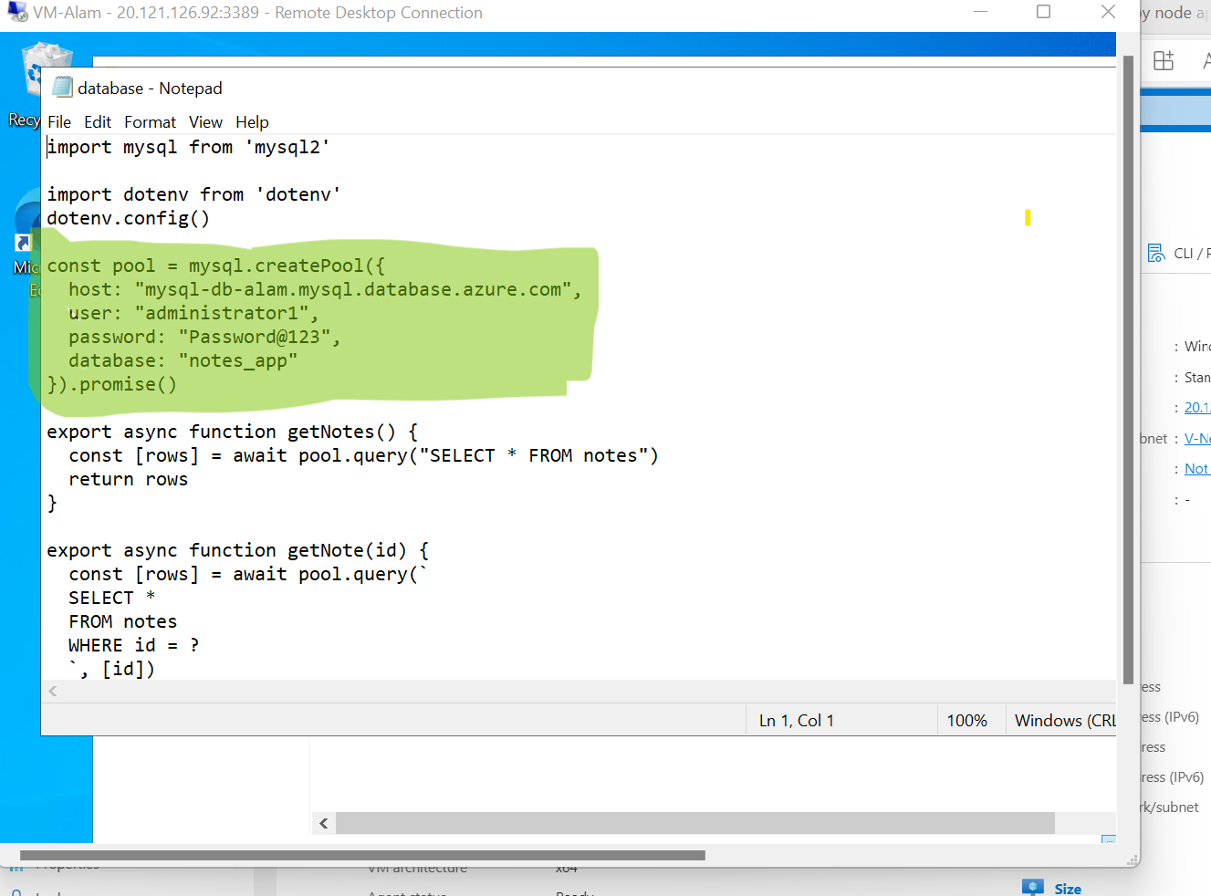

17. App is running and is listening on PORT-8080

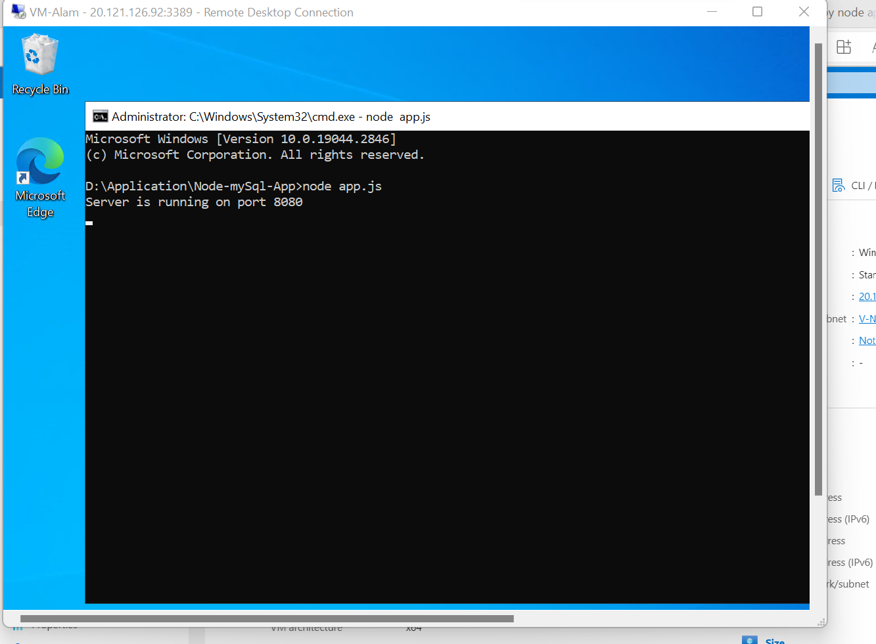

18. Testing application by sending request.

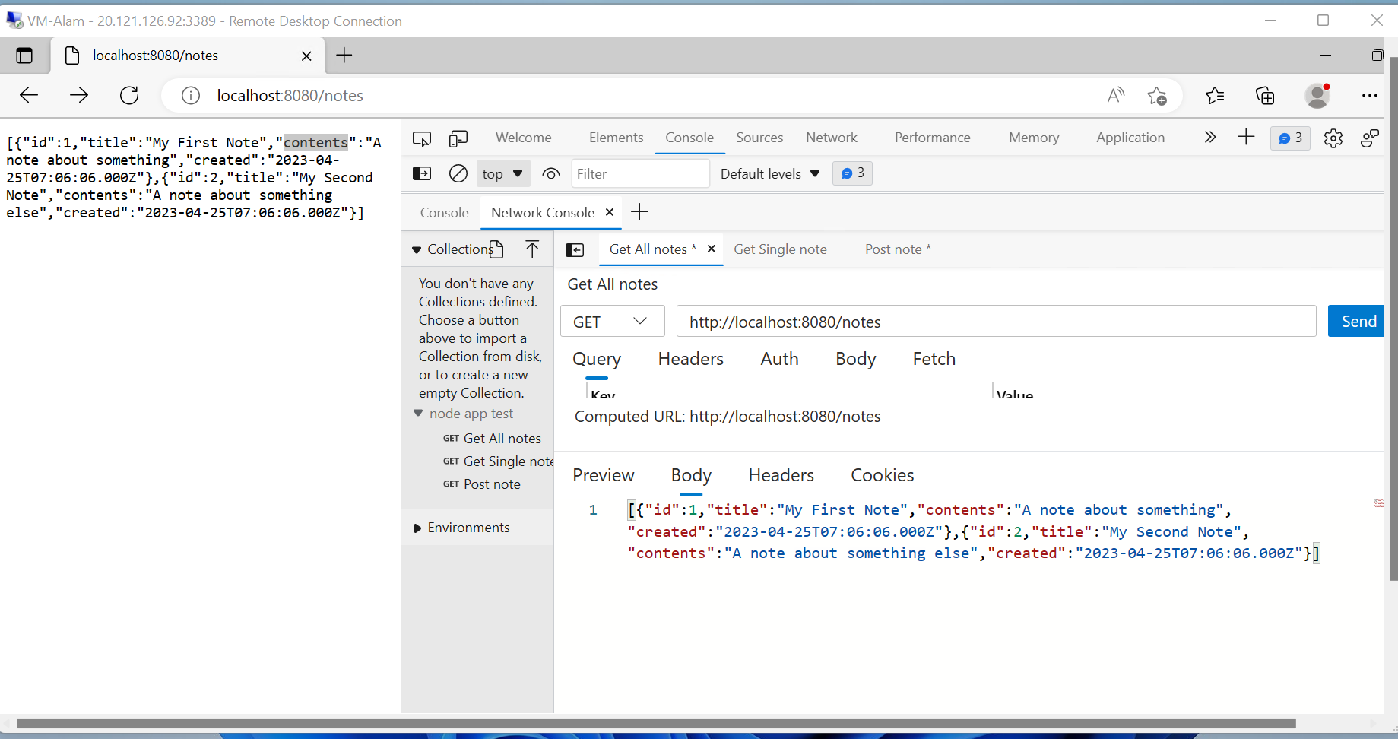

Azure App Service

1. Create App service

2. App Service - Created successfully

3. We can see that service is running successfully and is sending response for the GET and POST request.

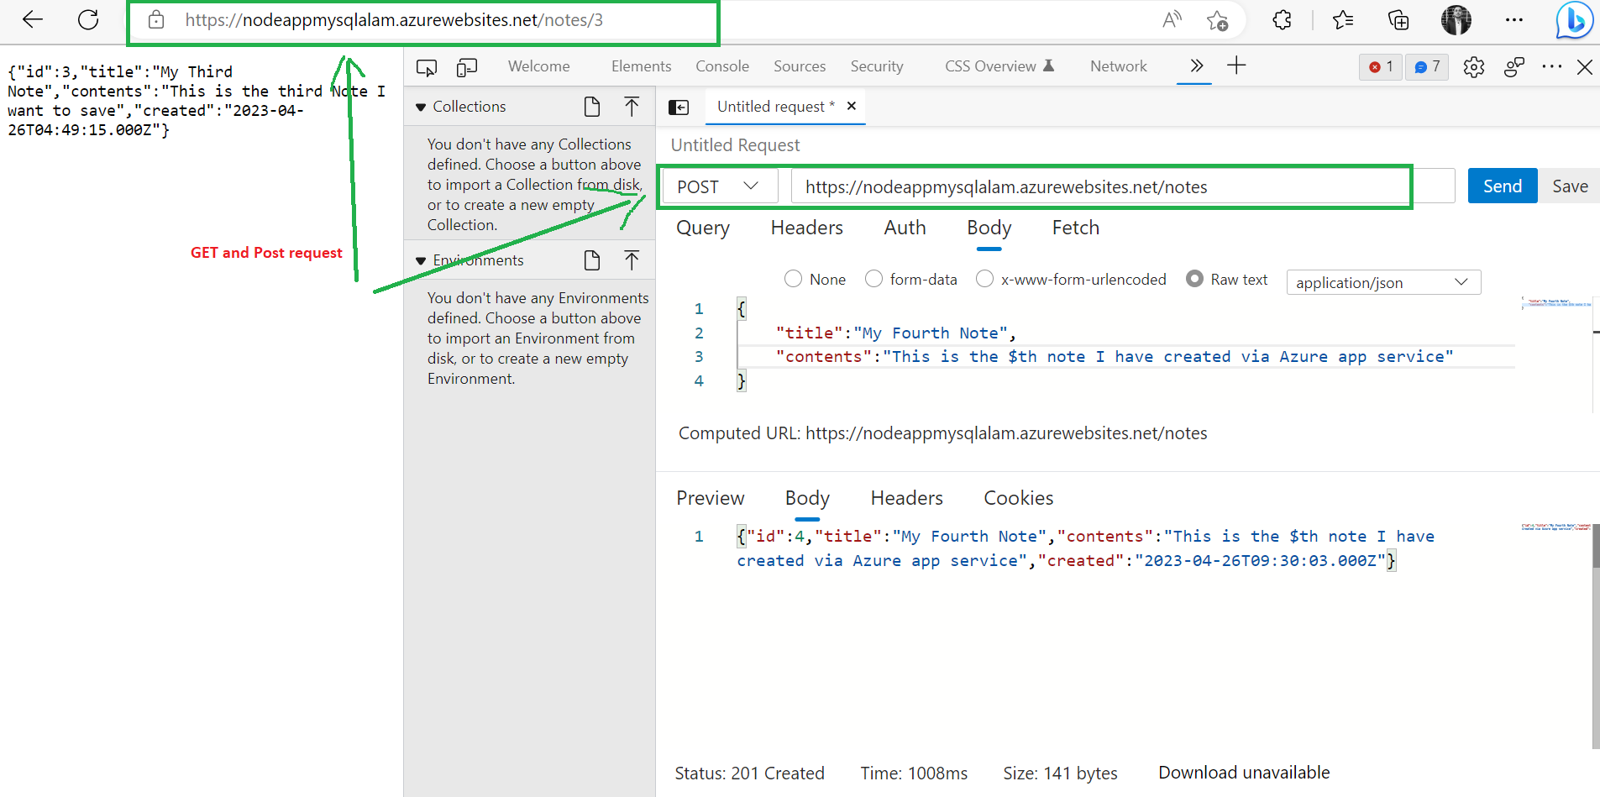

Azure Kubernetes Service

1. Create AKS

2. Successfully Created AKS

3. These are nodes which are available.

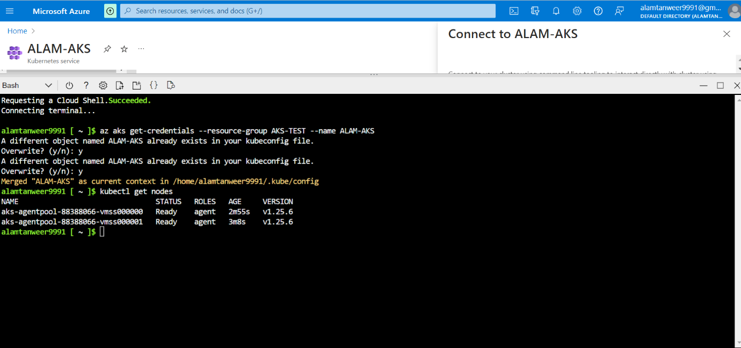

4. Applying the manifests to the AKS cluster using following command.

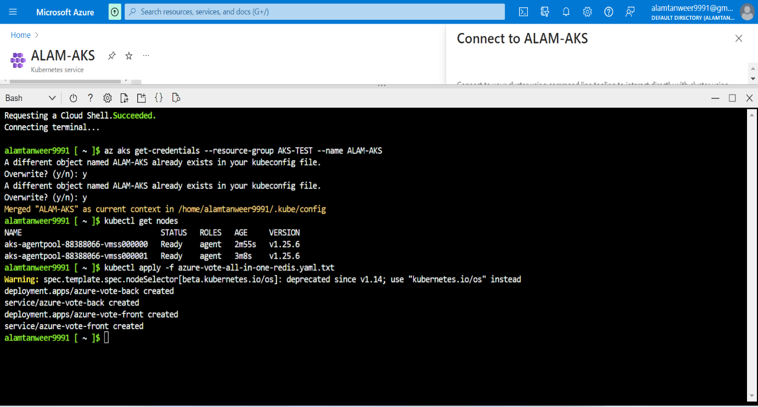

5. The service is running on that external IP address.

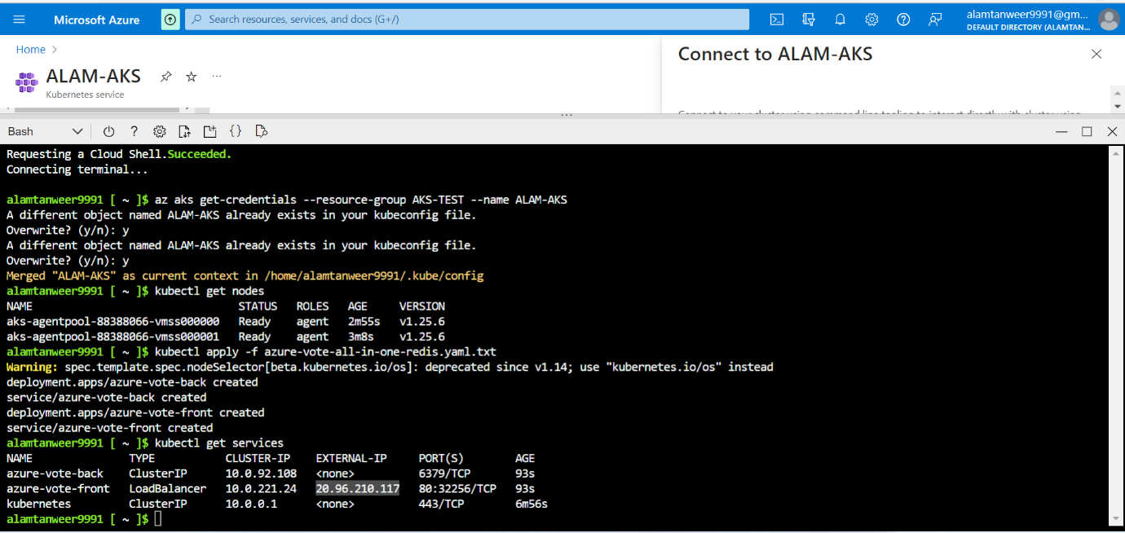

6. The service is also accessable via internet on that IP.

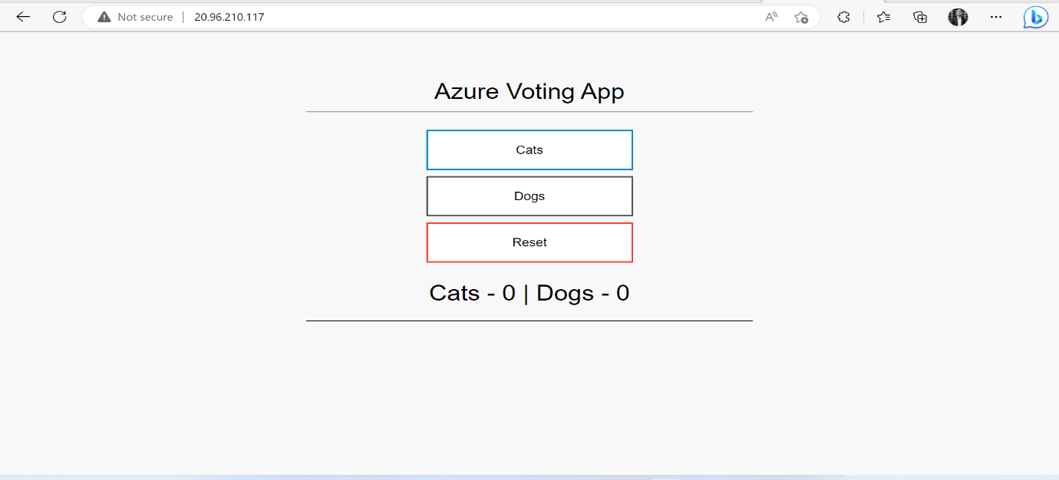

Azure Function

1. Currently don't have any storage accounts.

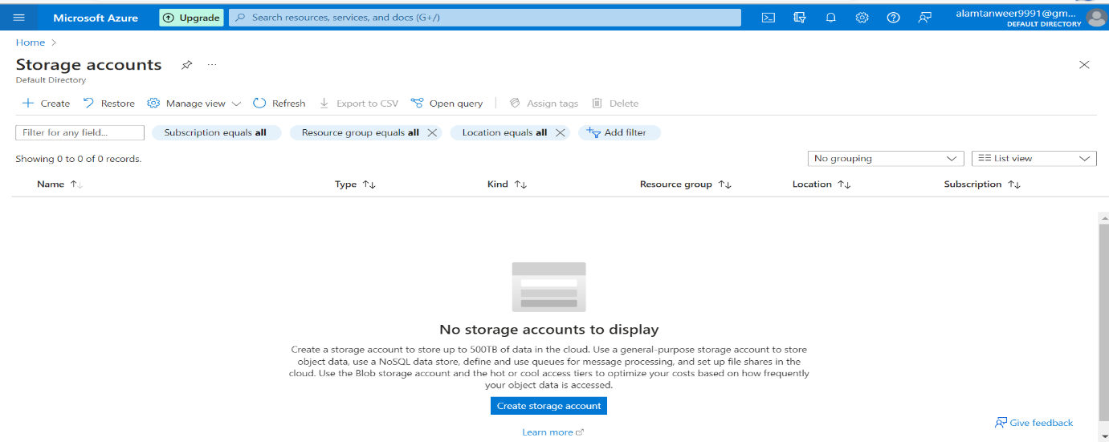

2. Storage account setup successfully.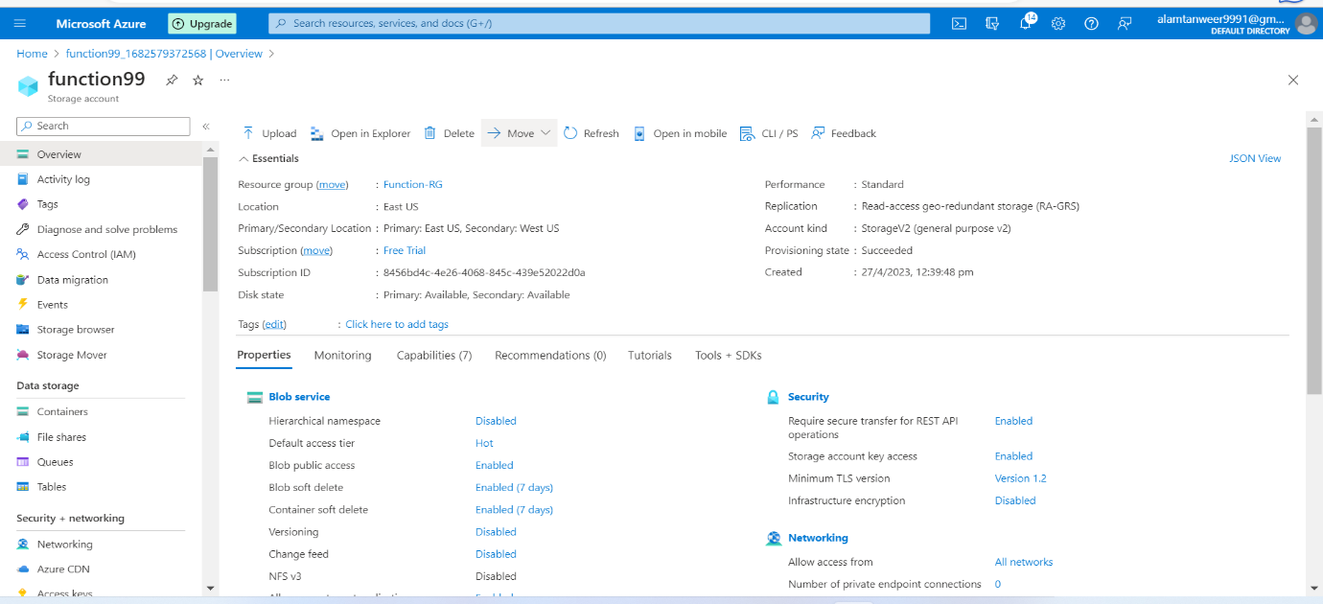

3. Start setting up Function APP.

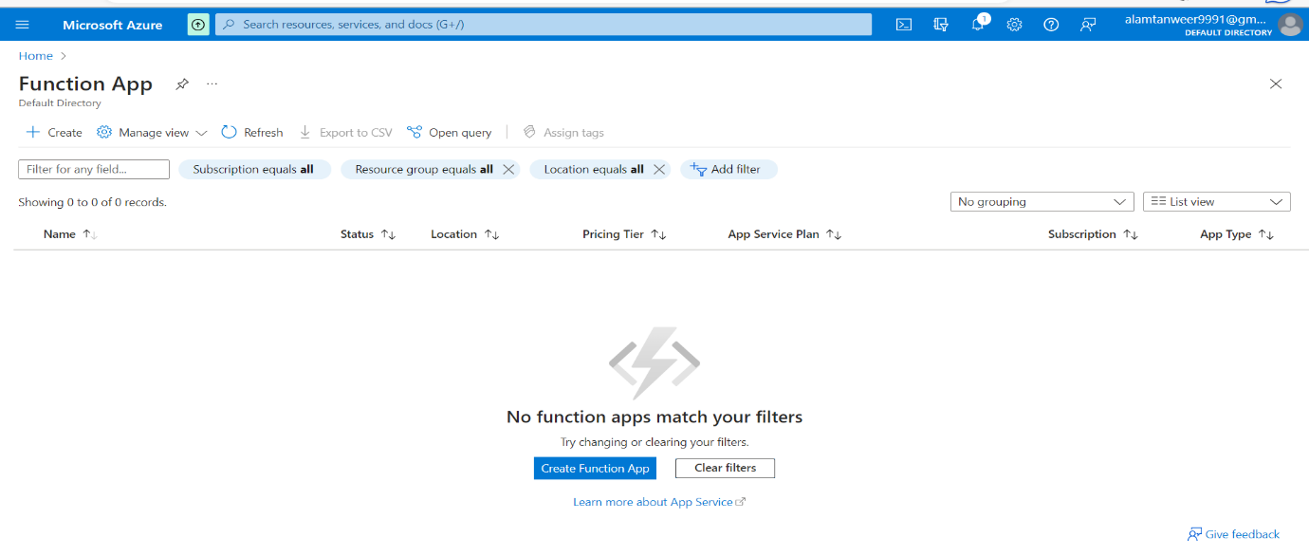

4. Function APP setup done successfully.

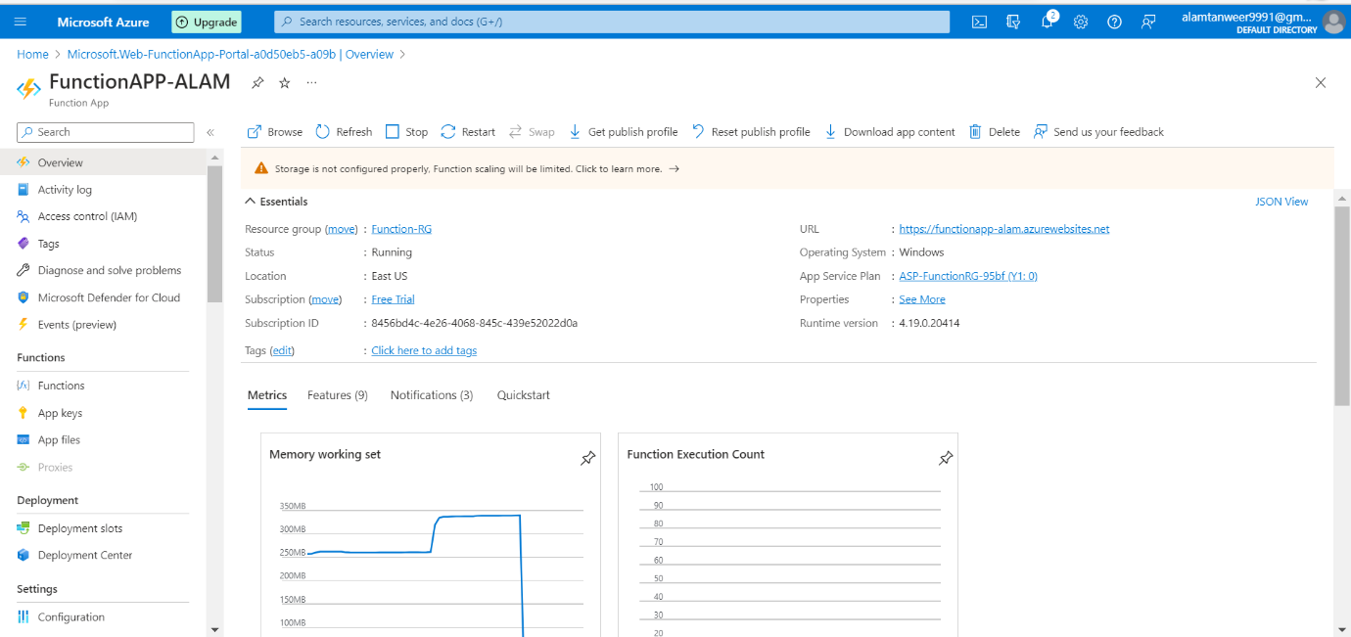

5. Creating BlobTrigger1 function into FunctionAPP service and setting the path and storage account.

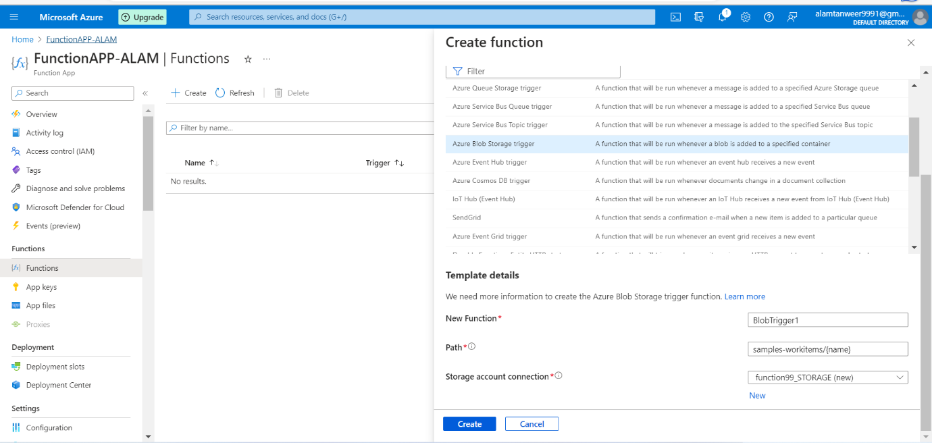

6. Function created successfully.

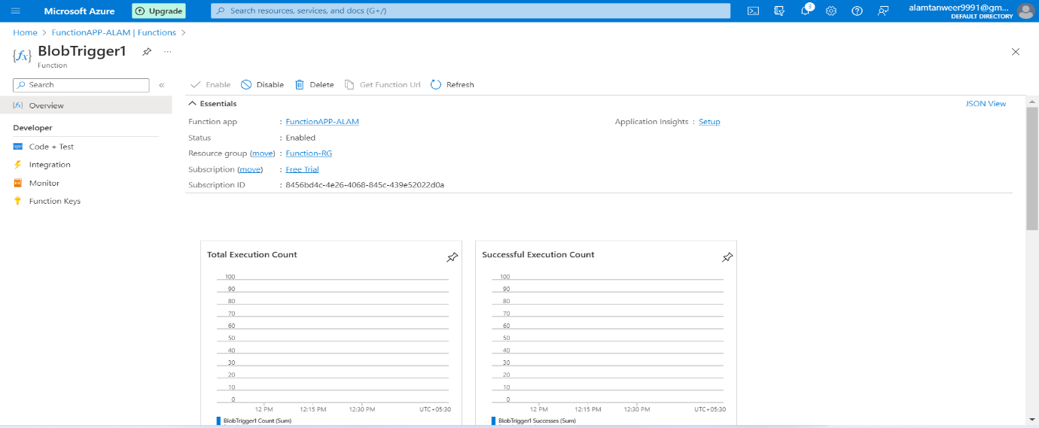

7. Creating container so that path matches with it.

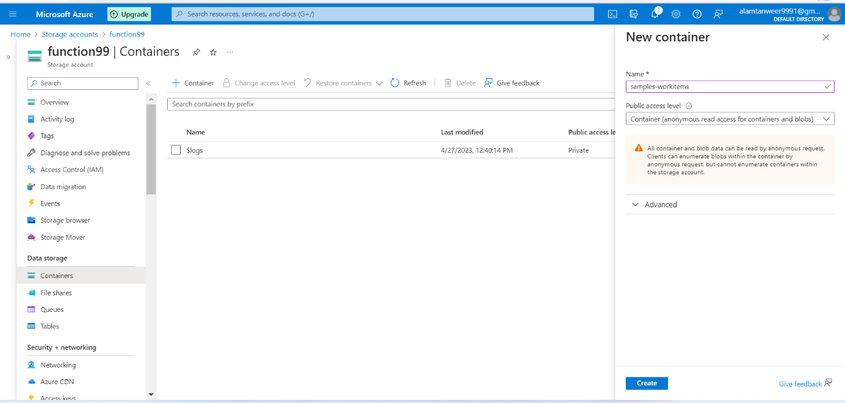

8. Container created successfully.

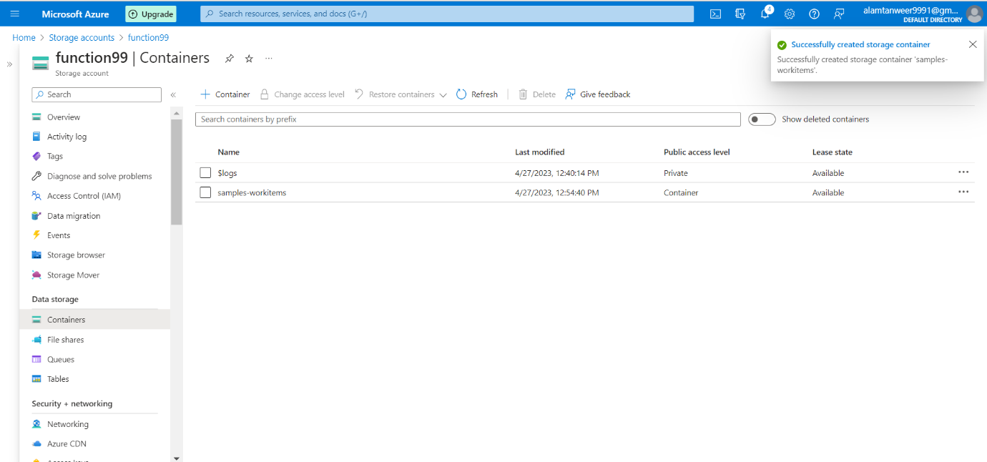

9. Uploaded file into container

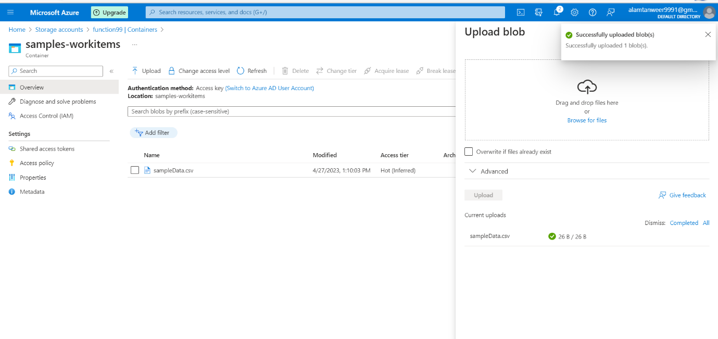

10. lets test the function whether it is printing the file name or not.

I’m not able to see logs after waiting an hour.

